**Note of Econ 103**

**Chapter 5**

Topics Macroeconomics concern:

* GDP
* inflation
* unemployment

Government role in economy:

* Fiscal policy
* Monetary policy
* Growth policy

Markets:

* Goods & service
* Money / Financial
* Labor

**Chapter 6**

* + Production located in the country
  + Aggregate Expenditure = C + I + G + (EX - IM)
    - C = Durable good + Nondurable good + service
    - I = Residential Investment + Nonresidential Investment + Change in Inventories
      * GDP = final sales + change in inventories
    - G = government spending
  + Aggregate Income = national income + depreciation + (indirect taxes - subsidies) + net factor payments to the rest of the world + other
* GNP
  + Production owned by a country’s citizen

Nominal GDP = current price $×$ current production

Real GDP = base year price $×$ current production

**Chapter 7**

Ideal economy:

* Low unemployment
* Low inflation
* Rapid growth of output per worker

Labor force:

* Over 16 years old
* Have a job or is looking for a job

Unemployed:

* Is not working
* Is available for work
* Has effort to find a job for previous 4 weeks

Labor force = employed + unemployed

People over 16 = in labor force + not in labor force

Unemployment Rate = unemployed / labor force

Labor force participation rate = labor force / population over 16

Natural unemployment = Frictional unemployment + Structural unemployment

**Chapter 8 Aggregate Expenditure & Equilibrium Output (without Gov)**

Aggregate income = Aggregate Expenditure = GDP (Y)

Y $≡$ C + S

C = a + MPC $∙$ Y ($0<b<1$)

MPC + MPS = 1

Change in Inventory = Production – Sales

* When Equilibrium: $Y=AE≡C+I$
* When $Y>C+I$

Actual investment is greater than planned investment

* When $Y<C+I$

Actual investment is greater than planned investment

Multiplier:

* Multiplier = $\frac{1}{MPS}=\frac{1}{1-MPC}$

$ΔY=ΔI×Multiplier$

**Chapter 9 Aggregate Expenditure & Equilibrium Output with Government**

After tax income: $Y_{d}≡Y-T$

Aggregate Expenditure: $AE≡C+I+G$ and $C=a+MPC×Y_{d}$

When equilibrium: $Y=AE=C+I+G$

Budget Deficit: $≡G-T$

(Leakages) S + T = I + G (Injections)

Multipliers:

* Government Spending Multiplier = 1 / MPS = 1 / (1 - MPC) and $ΔY=\frac{ΔG}{MPS}$
* Tax Multiplier = $-\frac{MPC}{MPS}$ and $ΔY=ΔT∙-\frac{MPC}{MPS}$
* Balanced Budget Multiplier = 1 and $ΔY=ΔG$

**Chapter 10 Money Supply and Federal Reserve System**

Money:

* Means of payment
* Storage of value
* Unit of account

M1 = current held + demand deposits + travelers’ check + other checkable deposits

M2 = M1 + savings + money market accounts + other near monies

Modern Bank System:

* Asset – liabilities = Net worth

|  |  |
| --- | --- |
| Asset | Liability |
| * Reserves * Loans | * Deposits * Net worth |

Excess reserve $≡$ actual reserve – required reserve

Creation of money:

* Actual Reserves $×$ Money Multiplier = Deposits created in banking system

$Money Multiplier=\frac{1}{required reserve ratio}$

How Federal Reserve controls money supply:

* Changing required reserve ratio
* Changing discount rate (New borrowed money become part of the reserve)
* Open market operation: purchase and sale government securities in open market

**Chapter 11 Money demand, the equilibrium interest rate and monetary policy**

Factors that affect demand for money;

* Transaction motive
* Speculation motive

So, when **Interest Rate (r)** is high, people would demand less **money (M)**

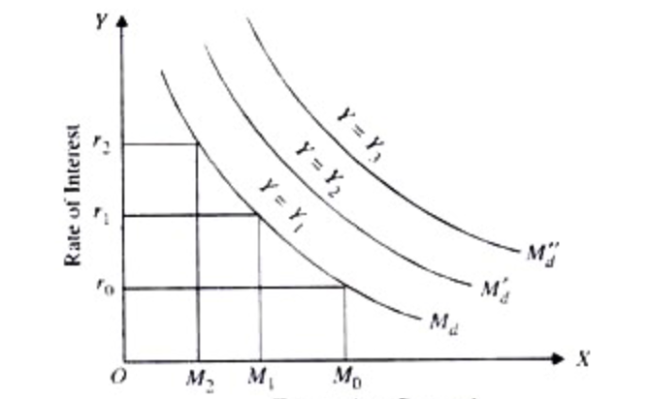

Property:

* $Y↑ ⇒M^{d}↑$ (Shift right)
* $Y↓ ⇒M^{d}↓$ (Shift left)

Money Demand and Supply Equilibrium:

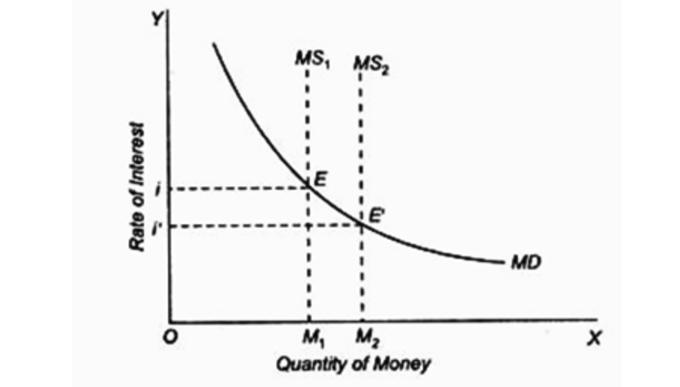

Money policy:

* Tight monetary policy
  + Contract money supply
* Easy monetary policy
  + Expand money supply

**Chapter 12 Aggregate Demand in the Goods and Money Markets**

Goods Market: $Y = C + I + G$ ( $I$ depends on *r*)

Money Market: $M^{d}=M^{s}$ (Money demand depends on Y)

$Y↑⇒M^{d}↑⇒r↑$

$r↑⇒I↓⇒AE↓⇒Y↓$

Expansionary fiscal policy: increase government spending / cut tax $⇒$ increase Y

Crowd-out Effect: $G↑⇒Y↑⇒M^{d}↑⇒r↑⇒I↓$

Expansionary Monetary Policy: $M^{s}↑⇒r↓⇒I↑⇒Y↑⇒M^{d}↑$

Contractionary fiscal policy: $G↓or T↑⇒Y↓⇒M^{d}↓⇒r↓⇒I↑$

Contractionary monetary policy: $M^{s}↓⇒r↑⇒I↓⇒Y↓⇒M^{d}↓$

Aggregate Demand (AD) curve: The higher the price level (P), the lower the aggregate e output

* Increase $M^{s}$, increase G or decrease T supply shift AD curve to the RIGHT, vice versa

**Chapter 13 Aggregate Supply and the Equilibrium Price Level**

Aggregate Supply (AS) curve is the total supply of all goods and services in the economy

In the short run: $Y↑ ⇒ P↑$ and

In the long run, AS curve is a vertical line, Y increase at the same rate as overall price level

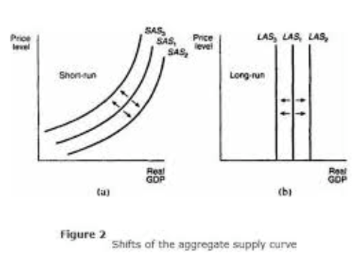h

Cost shock on Supply:

* Increase AS (shift right):
  + Lower cost
  + Economic growth
  + Public policy like cut tax, deregulation
  + Good weather
* Decrease AS (shift left):
  + Higher cost
  + Stagnation
  + Public policy like waste, inefficiency and over-regulation
  + Bad weather, war, disaster

Equilibrium Price Level:

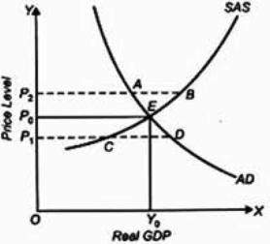

**Chapter 14 Labor Market**

Classic View of Labor Market:

* Labor force = employed + unemployed
* People over 16 = in labor force + not in labor force
* Unemployment Rate = unemployed / labor force
* Labor force participation rate = labor force / population over 16
* And labor market equilibrium:
  + 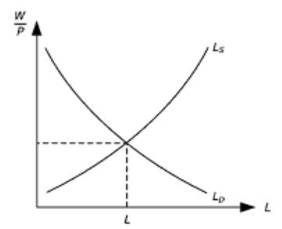
* Classical economists believe the labor market always clears
  + When wage rates raise up, labor supply will increase
  + Vice versa, when wage rates go down, people either accept job with lower wage or leave the job market

Beyond classical view:

* Sticky wage (wage fails to fall when demand decrease)
* Social / implicit contract (unspoken agreement not to cut wage)
* Explicit contract (set wage explicitly)
  + Cost of living adjustments (COLAs)
* The efficiency wage theory
* Imperfect information (wrongly set wage due to lack of info)
* Minimum wage laws

Short run Phillips Curve:

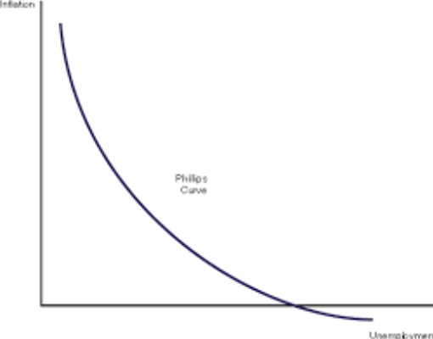

Phillips Curve fails to work in long run since both AD and AS are shifting and become vertical curve which intersect the x-axis at **natural rate of unemployment** ($U^{*}$), which is at potential GDP

NAIRU (The Nonaccelerating Inflation Rate of Unemployment)

Change in the Inflation Rate

Unemployment Rate, U

NAIRU

PP

0

Favorable shift is to the left, since we can have a lower NAIRU, which is caused by foreign competition

* Input price $↑ ⇒$ SPAS to the left, SRPC and PP to the right
* Inflationary expectation $↑ ⇒$ SRAS to the left, SRPC and PP to the right
* Foreign competition $↑ ⇒$ SRAS to the right, SRPC and PP to the left

**Chapter 15 Financial Crisis, Stabilization and Deficits**

Ways to obtain money:

* Bank loan
* Bond issuance (Public debt)
* Stock (Ownership if a firm)

Factors that affect price of stock

* Expectation of future profits
* Expectation on what others would pay

Index to measure Stock Market:

* Dow Jones Industrial (30)
* NASDAQ (Over 5000)
* Standard and Poor’s 500 (500)

**Time lags** that make stabilization policy not work:

* Recognition Lag (statistic)
* Implementation Lag (congress)
* Response (operation of economy itself)

Cut in government spending cause economy to contract, and decrease tax revenue, increase transfer payment

Deficit Response Index (DRI):

$ΔY=ΔG×Government Spending Multiplier$

$ΔD=ΔY∙DRI$

$D=D_{0}+ΔD$